Tenda W6-S – How to configure Network settings

- Click on “Wireless”, then click “Channel Scan” to see the details of channel around you.

Usage Scenario: Scan the channel around you If you want to change another channel on the “RF” option but you are not sure which channel is appropriate to your situation.

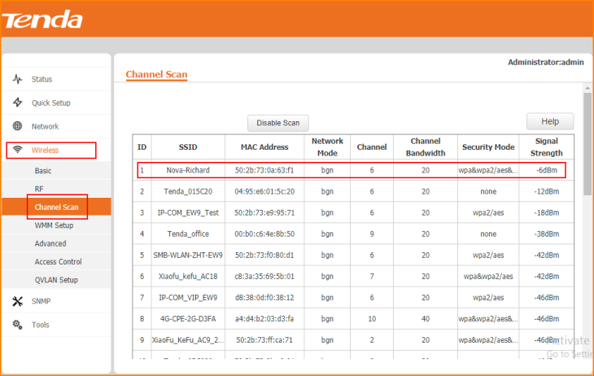

- Click on “Wireless” and click “WMM Setup”, “Enable” the option is recommended.

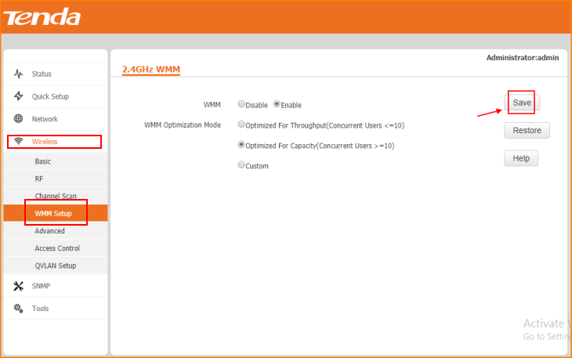

- Click on “Wireless” and click “Access Control” to edit the devices are connected to the W6-S If you want to filter some devices MAC Address.

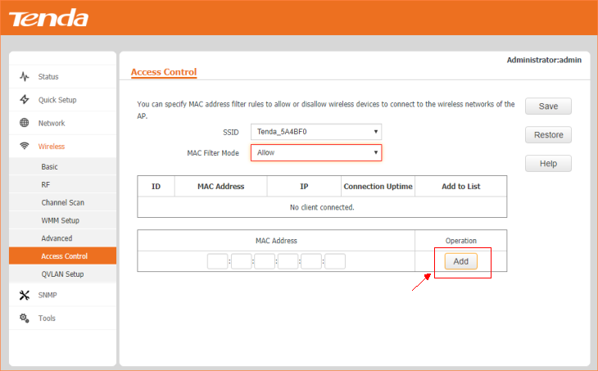

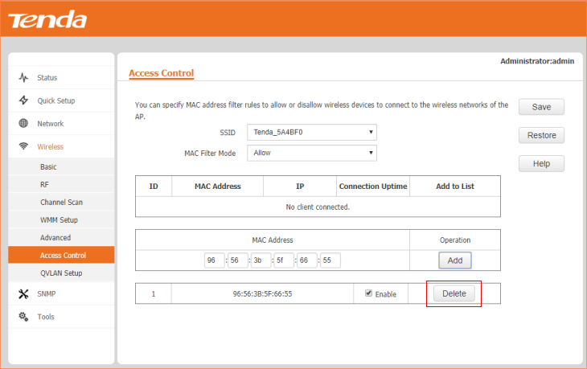

Note: Remember to “Save” the configuration.

- Click on “Wireless” and click “QVLAN Setup”, then you can configure VLAN for W6-S.
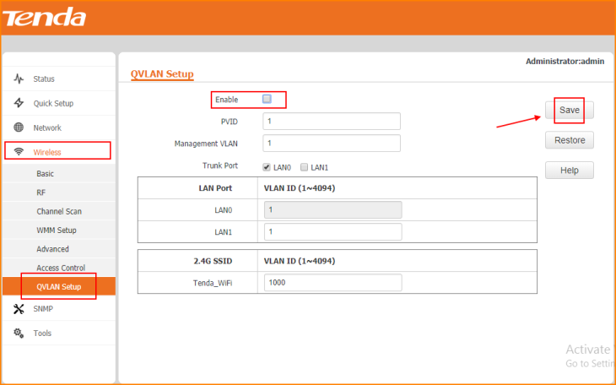

Note: Remember to “Save” the configuration.

